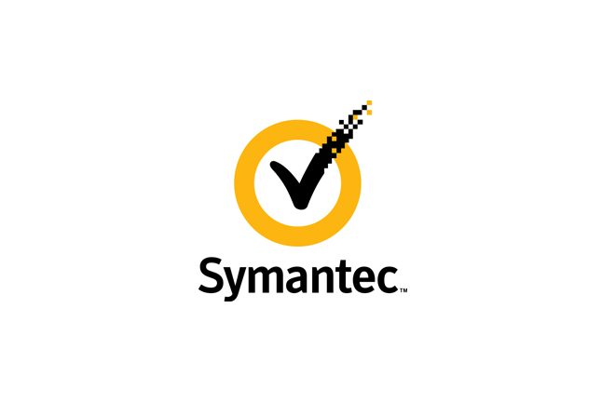

**Symantec Case Analysis**

Samuel Akinfenwa| CIS 410-01| 9/23/20

# Introduction

# Symantec is a software production company for the information management, productivity, and software development needs of business users. The company had experienced rapid growth in the software industry and it’s a big player. During its growth, Symantec acquired three more companies, but the companies stayed in their original location. The growth had brought concerns that could affect the company’s future. The concerns were expressed by the employees who felt the company internal processes (information flow) was not good enough.

The CEO, Gordon E. Eubanks did not believe in imposing a culture in the product group. “The nature of a culture is found in its social norms and customs and that if one adheres to these rules of behavior one will be successful in constructing an appropriate social reality.” (Morgan). Eubank's effect on the company’s culture lack of effective communications and control.

The Company’s structure was diverse and broad. It had different product groups with multiple divisions and departments. The product groups had a manager that was involved in all the stages of the product’s life cycle. Symantec had technical support departments within each product group and a centralized customer service department. “Differentiation is aimed at the broad market that involves the creation of a product or services that is perceived throughout its industry as unique.” (Porter) The company structure meant the communication and control must be on par, but it did not seem so. Despite the executives try to keep things in check, the company could handle its large expansion.

The continual failure of the network system and phone line with the reliance on an out of date technology attributed the company struggles with consistent communications and structured information flow. The MIS department, assigned to fix the systems failures or technological problems, struggled to implement a solution to the constant failures, delayed employee's help request, and lacked help from management. The rapid growth of Symantec also did not help the MIS department provided time or resources to devise and implement an effective MIS Strategy

Symantec was a big player in the software industry, its growth was rapid. Symantec executives and managers struggled to keep the information flowing or find a solution to its communication and technology problems. Some Employees and managers were not trained well and lacked leadership. Symantec needed to amine itself and find solutions to its problems.

Industry Competitive Analysis

* **Competitive Rivalry** – Symantec was a growing company competing with well-established companies like Lotus and Ashton-Tate. Symantec had to establish itself as a major player in the industry to compete. *high*
* **The threat of New Entrants** – In the technology and software industry, the threat of new entrants is very high because technology is always changing. New and Improved technology often pose threat to old technology in the market. Symantec upgraded and developed versions of its old products to stay a leader in their respective marker. *high*
* **The Threat of Substitutes** – The threat of substitutes is low since only a few companies offered what they offered. Their service is also great and it’s something they pride themselves upon. *low*
* **Bargaining Power of Suppliers** – Symantec Supplier (Hewlett-Packard) was an information technology firm that provided its accounting system, inventory control, and manufacturing schedules. If the suppliers increased their cost, Symantec would have to make changes to their product price or change the suppler to keep their product price. *Medium*
* **Bargaining power of Customers** – Customers in the industry, have options to choose from because the competition is very high. Customers could easily switch if they are not satisfied with Symantec products or services. *High*

# Stakeholders

**Executives** – The CEO, the COO, and other top executives are massive stakeholders in the company. They have to make sure the company is functioning well and improving. They will also have figured out the company structures and strategies to help fix their problems. It is easier to fix the blame than to fix the problem. (Barker)

**Employees –** The employees are impacted by the decision of the executives and managers. The functionality of the company depends on them.

**Customers –** Symantec customers expect quality services and products.

**Managers -** they are coordinators, developers, and organizers of the company. They also in charge of the products group.  
Decisions

Do nothing

This decision will change nothing in the company. Reoccurring problems will continue to grow. There will be a steady decline in the company's ability to function. Symantec competitors will take advantage of its decline. Symantec will lose customers and its major status in the industry; A competitor might even try to purchase the company. This decision could lead to employees leaving or put limiting effort. The company culture is be damaged and its employees will lose respect for its executives and managers.

The company growth will end, and it will continue its “fire-fighting” methodology that does not allow them to properly research and implement the correct hardware and software for the company. The MIS department will face the worst damage if nothing is done. Symantec relies heavily on the MIS department to provide a solution. The Department might be canceled if a new technological system is not installed. Symantec might lose its acquired companies to its competitors.

Improve Communication Systems and Technologies

“Change, change, change: Create it or die from it.” (Kalakota 118) Before changes can be made, Symantec executives and management need to improve their decision making and get rid of policies that are a benefiter. The biggest needs to be a cultural change. Eubanks needs to implore a culture that encourages communications. Eubanks needs to acknowledge its top executive to stress the importance of sharing information. Dykes stated for communication to advance in the companywide it depended on the management's willingness to communicate.

Symantec problems were temporary but vital. Employee's frustration in the HP system showed its time for a change. Symantec needs to get rid of the in-house production of the software that creates problems. It may cost more but a need system needs to be bought. The network system also had its letdowns. Rather than compensating for the current system, Symantec needs to purchase the best communication system. It will be expensive, moving on from the MIS

based support of the system is beneficial.

The MIS department seems to lack leadership to function at the best level and provide the company with the best communication and HP system. New management is needed in the MIS System so they can stop spending time-fighting fires instead create an innovative solution to replace the old systems. Also, the Systems should not rely heavily on the MIS Department, but users need to be trained and be accountable for their use. “We have to stay on the leading edge of technology. It’s essential to the company. If we don’t keep pace with technology, we’re finished” (Goldratt 39)

Limit Communication Systems and Technologies

Some employees complained there were too many ways to communicate. Symantec could implement a limited number of communication systems and procedures, so they will effective communication and less stress over how the information is sent. The communication must be structured to make it more effective. The limited communication systems will help the management establish a policy where communication is expected. With the right technology for communication like the full email package, Symantec can lower the stress of the employee and reduce the reliance of the MIS system. A unified communication system throughout all locations of Symantec should greatly increase the reliability of communication and having reliable communication will lead to, increase production and increase throughput.

# Recommendation

According to Goldratt's statement, we need to stay updated with technology and keep up the pace. Communication is vital to organizational success. The systems used for communication are just vital so the right systems must be implemented so the communication is effective. The system users must be well-trained and capable to solve small issues in the system without support.

I recommend the improvement the communications systems and technologies. The company is growing, and it needs an updated system to function to full capabilities. Technology is ever-growing and changing, more communication systems will help Symantec control systems and information flow improve drastically.

Works Cited

Morgan, G. (1997). Images of Organization (2nd ed.). Thousand Oaks, Calif.: Sage Publications.

Barker, Management Information Systems, Porter’s Concepts of Generic Strategies

Barker, The Rules of Bureaucracy

Kalakota, Ravi, Marcia Robinson, and Ravi Kalakota. E-business 2.0: Roadmap for Success. Boston, MA: Addison-Wesley, 2001.

Goldratt, E. M., & Cox, J. (2014). The Goal: A Process of Ongoing Improvement. (3th rev ed.). GreatBarrington, MA: North River Press.